**LAB ACTIVITY**

**PENGOLAHAN CITRA DIGITAL**

**Pertemuan 8 – Perbaikan Kualitas Citra (Part 1)**

|  |  |
| --- | --- |
| Nama: Muhammad Rifqi Amir Putra | NPM: 062230701416 |
| Kelas: 5 CA | Mata Kuliah: Pengolahan Citra Digital |

**Alat dan Bahan:**

1. Text Editor
2. Python
3. Library Python numpy, opencv, matplotlib
4. Google Colab (Opsional)
5. **Perbaikan Kualitas Citra Menggunakan Python**
6. **Pencerahan Citra (Image Brightening)**

1. **Menegatifkan Citra (Image Negatives)**

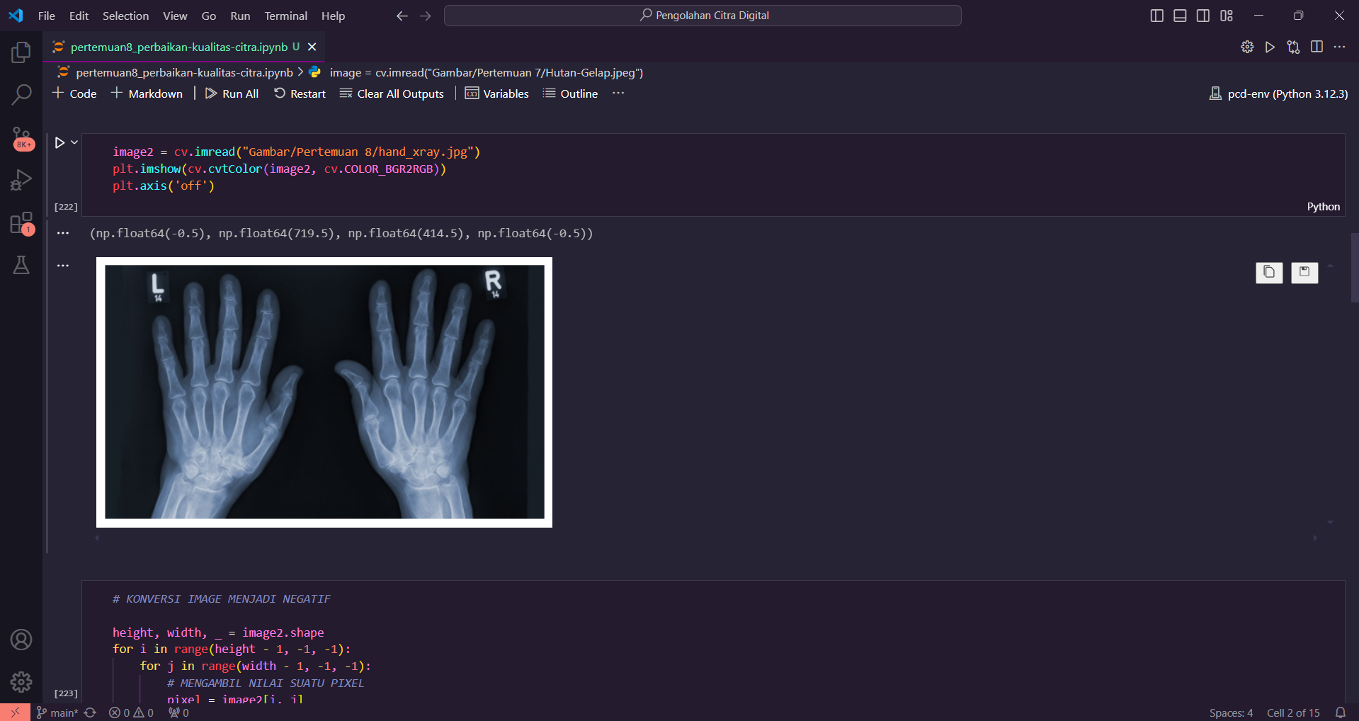

1. **Gamma Correction**

1. **Peregangan Kontras (Contrast Stretching)**

